Introduction to Amazon EC2

**Overview**

This lab provides you with a basic overview of launching, resizing, managing, and monitoring an Amazon EC2 instance.

**Amazon Elastic Compute Cloud (Amazon EC2)** is a web service that provides resizable compute capacity in the cloud. It is designed to make web-scale cloud computing easier for developers.  
Amazon EC2's simple web service interface allows you to obtain and configure capacity with minimal friction. It provides you with complete control of your computing resources and lets you run on Amazon's proven computing environment. Amazon EC2 reduces the time required to obtain and boot new server instances to minutes, allowing you to quickly scale capacity, both up and down, as your computing requirements change.

Amazon EC2 changes the economics of computing by allowing you to pay only for capacity that you actually use. Amazon EC2 provides developers the tools to build failure resilient applications and isolate themselves from common failure scenarios.

**Topics covered**

By the end of this lab, you will be able to:

* Launch a an EC2 Instance
* Terminate your EC2 instance.

**Start Lab**

**Task 1: Launch Your Amazon EC2 Instance**

In this task, you will launch an Amazon EC2 instance with *termination protection*. Termination protection prevents you from accidentally terminating an EC2 instance. You will deploy your instance with a User Data script that will allow you to deploy a simple web server.

1. In the **AWS Management Console** on the **Services** menu, click **EC2**.
2. At the top right of the screen, if you see **New EC2 Experience** toggle to use the new UI. It is enabled by default.
3. Click **Launch instance** > **Launch instance**.

Provide the follow information under

## Launch an instance

## Step 1: Name and tags

## Provide a tag value for your instance example 🡪 Linux-Server

## 

 Tags enable you to categorize your AWS resources in different ways, for example, by purpose, owner, or environment. This is useful when you have many resources of the same type — you can quickly identify a specific resource based on the tags you have assigned to it. Each tag consists of a Key and a Value, both of which you define.

**Step 2: Application and OS Images (Amazon Machine Image)**

 An **Amazon Machine Image (AMI)** provides the information required to launch an instance, which is a virtual server in the cloud.

An AMI includes:

1. A template for the root volume for the instance (for example, an operating system or an application server with applications)
2. Launch permissions that control which AWS accounts can use the AMI to launch instances
3. A block device mapping that specifies the volumes to attach to the instance when it is launched

The **Quick Start** list contains the most commonly used AMIs. You can also create your own AMI or select an AMI from the AWS Marketplace, an online store where you can sell or buy software that runs on AWS.

* Click **Quick Start**
* Select **Amazon Linux AWS**
* Under **Amazon Machine Image (AMI**) select **Amazon Linux 2 AMI** (HVM) (make sure it says **Free tier eligible**)

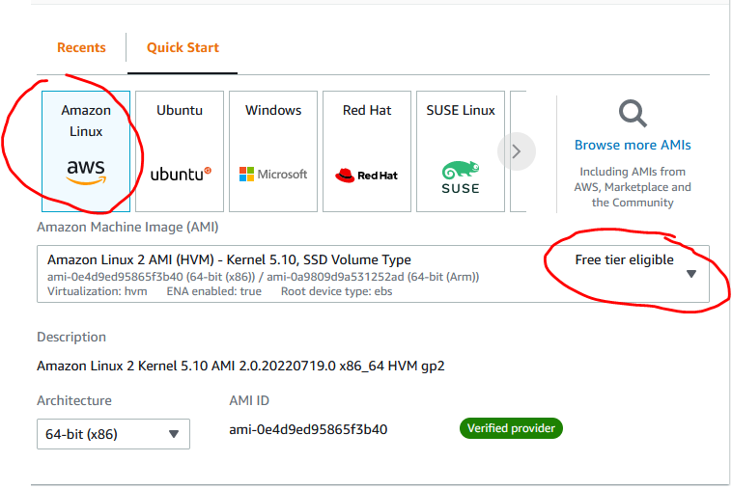

**Step 3: Instance Type**

 Amazon EC2 provides a wide selection of *instance types* optimized to fit different use cases. Instance types comprise varying combinations of CPU, memory, storage, and networking capacity and give you the flexibility to choose the appropriate mix of resources for your applications. Each instance type includes one or more *instance sizes*, allowing you to scale your resources to the requirements of your target workload.

* Click on the drop down and select  **t2.micro**.
  + A **t2.micro** instance type has 1 virtual CPUs and 1 GiB of memory.

## Step 4: Key pair (login)

* Select an existing key pair or create a new key pair.
  + Please refer to previous lab and use the Keypair that was created.

*Do not create multiple keypair per region.*

 Amazon EC2 uses public–key cryptography to encrypt and decrypt login information. To log in to your instance, you must create a key pair, specify the name of the key pair when you launch the instance, and provide the private key when you connect to the instance.

* Click the **key pair** **name** drop-down and select Procced without a keypair

**Step 5: Network settings**

This includes networking settings.

The **Network** indicates which Virtual Private Cloud (VPC) you wish to launch the instance into. You can have multiple networks, such as different ones for development, testing and production.

* Leave thing section as default.

**Step 6: Configure storage.**

 Amazon EC2 stores data on a network-attached virtual disk called *Elastic Block Store*.

You will launch the Amazon EC2 instance using a default 8 GiB disk volume. This will be your root volume (also known as a 'boot' volume).

* Leave this section as default

**Step 7: Advance details**

Leave this section as default.

* Click **Launch Instances**

Your instance will now be launched.

* Click **View Instances**

The instance will appear in a *pending* state, which means it is being launched. It will then change to *running*, which indicates that the instance has started booting. There will be a short time before you can access the instance.

The instance receives a *public DNS name* that you can use to contact the instance from the Internet.

Select Your **Linux-Server** and the **Details** tab displays detailed information about your instance.

 To view more information in the Details tab, drag the window divider upwards.

Review the information displayed in the **Details** tab. It includes information about the instance type, security settings and network settings.

* Wait for your instance to display the following:
  1. **Instance State:**  running
  2. **Status Checks:**  2/2 checks passed

**Congratulations!** You have successfully launched your first Amazon EC2 instance.